System Requirements Statement (SRS)

Online driver hiring system

Doc. Ref. :

Version : 0.4

Status : Drafted

Created by : Kenji Tanaka

Date : 04-Dec-2012

1. Introduction 3

2. Functional Requirements 4

2.1 Customer Module 5

2.2 Driver Module 9

2.3 admin Module 14

2.4 Use Case Diagram..............................................................................................................................18

THIS DOCUMENT CONTAINS 21 NUMBERED PAGES

# Introduction

This document explains the system requirements and scope for developing Online driver hiring System.

Online driver hiring System is divided in three main parts: Customer part, Driver part and Admin part.

This document describes the system requirements of each part.

# Functional Requirements

The Account part of Online Driving Hiring System has three modules which are divided 27 processes described as below.

|  |  |  |
| --- | --- | --- |
| **No** | **BRS requirement ID** | **Description** |
| **2.1** | **Customer Module** | |
| **2.1.1** | **F1** | **Registration Process** |
| **2.1.2** | **F2** | **Login Process** |
| **2.1.3** | **F3** | **Forgot Password Process** |
| **2.1.4** | **F4** | **Update Account Process** |
| **2.1.5** | **F5** | **Book ride** |
| **2.1.6** | **F6** | **View Ride Details** |
| **2.1.7** | **F7** | **Cancel Ride** |
| **2.1.8** | **F8** | **Delete Account** |
| **2.2** | **Driver Module** | |
| **2.2.1** | **F9** | **Login Process** |
| **2.2.2** | **F10** | **Forgot Password Process** |
| **2.2.3** | **F11** | **Update Account Process** |
| **2.2.4** | **F12** | **Browse Available Rides & confirm ride** |
| **2.2.5** | **F13** | **View Ride Details** |
| **2.2.6** | **F14** | **Pay to Company** |
| **2.2.7** | **F15** | **Cancel Ride** |
| **2.2.8** | **F16** | **View Ratings** |
| **2.3 Admin Module** | | |
| **2.3.1** | **F17** | **Login Process** |
| **2.3.2** | **F18** | **Forgot Password Process** |
| **2.3.3** | **F19** | **Update Account Process** |
| **2.3.4** | **F20** | **View all daily scheduled rides.** |
| **2.3.5** | **F21** | **View rides history of customer & driver** |
| **2.3.6** | **F22** | **Add new city & routes details in the database** |
| **2.3.7** | **F23** | **Register New Driver** |
| **2.3.8** | **F24** | **Enable/Disable Accounts** |
| **2.4 Use Case Diagrams** | | |
| **2.4.1** | **F25** | **Customer** |
| **2.4.2** | **F26** | **Driver** |
| **2.4.3** | **F27** | **Admin** |

## Customer Module

* Customer is the user of system who wants to hire driver.

### Registration Process

* Online Driver Hiring System compels to create the account before using it. So, system should provide the function which makes Customer creates new account.
* When Customer creates new account, the function demands information described as below.
* The User information

The User information consists of some items described as below.

1. First Name
2. Last Name
3. Email Address
4. Contact
5. Password
6. City
7. State
   * All items are compulsory demanded.
   * Email Address

* The Email Address should be unique.
  + Password
* The Password has constraints which makes the Password consists of more than or equal 8 and less than or equal 12 characteristics including characters described as below.

1. Numeric figure (at least one)
2. Capital alphabet (A-Z)(at least one)
3. Small alphabet (a-z)(at least one)
4. Special character (#, $, %, &, etc.) (at least one)

* The Password is masked by dummy characters. The re-entering Password is demanded.
* The Password must be encrypted in Online Driver Hiring System.
  + Address
* City should be selected from options.
* State should be selected from options.
* The Security Question information

The Security Question information is needed when customer lost their Password. This information consists of two items described as below.

1. Selected Question
2. Answer
   * All items are compulsory demanded.
   * Some questions which are difficult to answer for anyone else are prepared in advance.

E.g. which color do you like most?

* + A question should be selected from options by the Customer, and the Answer is registered by the Customer.
* All required registration information should be entered on single screen.

### Login Process

* Online Driver Hiring System always compels user authentication before using itself except when a new account is successfully created.
* The user authentication demands Email Address and Password. The Email Address and the Password should be checked in two ways.
  + First, The Email Address and the Password should be Entered and correct.
* If The Email Address and the Password are not equal to what the user has registered, the user authentication cannot be provided.
  + Second, the User Type linked to the Email Address should be "Customer".
* When the User Type is "Customer", then user can be placed on “Customer Home”.
* The “Customer Home” provides the some items described as below.

1. A trigger to logout.
2. A trigger to update Account.
3. A trigger to book Ride.
4. A trigger to ride Details.
5. A trigger to cancel Ride.
6. A trigger to make a Payment.
7. A trigger to view ride history.
8. A trigger to rate & review driver.
9. A trigger to delete account.

### Forgot Password Process

* When system user lost their Password, the recovery method should be provided by Online Driver Hiring system.

The recovery method is described as below.

* + First, system user enters their Email Address for Online Driver Hiring System.
  + Next, Online Driver Hiring demands the Answer which has been registered since when the Account was created.
  + Only when the Answer is correct, Customer get the old password by E-mail which also has been registered since when the Account was created.
* If the Answer is not correct, otherwise, the correct Answer is demanded for user again.
  + In that case, of course, he can contact company.

### Update Account Process

* Online Driver Hiring System should provide the function which makes the account updated for Customer.
* The information customer could update is described below.

1. User information
2. Security Question Information

* The User information

The updatable items as described below.

1. First Name
2. Last Name
3. Email ID
4. Customer Contact
5. City
6. State
   * All items are compulsory demanded, but updating is optional.

* The Security Question information

The updatable items as described below.

1. Selected Question
2. Answer
   * All items are compulsory demanded, but updating is optional.

* When Customer wants to change their Password, the measure should be provided by Online Driver Hiring System.
  + The function demands the current password and the new password.
    - Of course, the new password should consist of more than or equal 8 and less than or equal 12 characteristics including at least a numeric figure, a capital alphabet, a small alphabet, and a special character.
    - The current password and the new password are masked by using dummy characters.
    - The new password is demanded to enter twice to avoid a typing error.
  + Only when the current password is correct, Customer could change his Password.
  + When the current password is changed into new password, Online Driver Hiring System compels user authentication again.

### 2.1.5 Book Ride

* The customer can create new ride query by selecting following particulars:

1. Pickup City & Destination City
2. Ride Start Date & Ride End date
3. Pickup Time

* Pickup City & Destination City:
* The customer should be able to select the pickup and destination cities from the dropdown list, which are mentioned in the database.
* Ride Start Date & Ride End date:
* The customer should be able to select the ride start date & ride end dates from the calendar.
* The calendar should be disabled for the date on which booking is being done and the days after 15 days of date on which booking is being done.
* Pickup Time:
* The clock should be provided in the booking form, so that, exact pickup time can be mentioned.
* After submitting the form, customer should be able to provide the pickup address.
  + The pickup address will be used to direct the driver to reach at the exact pickup location.
* After providing address, total fare of the ride can be displayed to the customer, where he can confirm ride or cancel the request.
  + According to the pickup city, destination city, ride start & ride end dates selected by driver, the total fare will be generated from the database.
* After confirming, the customer can see the summary page which contains following details:

1. Pickup City
2. Destination City
3. Ride Start Date
4. Ride End date
5. Pickup Time
6. Pickup Address
7. Total Fare

### View Ride Details

* In the booking dashboard, customer can view upcoming and past ride details containing following information:

1. Booking ID
2. Date of Booking
3. Pickup City
4. Destination City
5. Ride Start Date
6. Ride End date
7. Pickup Time
8. Pickup Address
9. Total Fare
10. Driver Name
11. Driver Contact
12. Ride Status
13. Ratings
14. Reviews

* Booking ID:
* The booking ID will be automatically generated, which can be used for tracking the ride, payment tracking and in case of discrepancy.
* Ride Status:
* After booking, the status will be “Pending”.
* After driver confirmation for the ride, the status will update to “Ride Confirmed”.
* Customer can confirm the ride start by clicking on the button in the dashboard, which changes the status to “Ride started”.
* Customer can end the ride, which changes the status to “Ride ended”.
* After the customer pays the fare to the driver for the current ride, after confirmation from the driver for the same, the status will be updated to “Ride successfully completed”.
* If customer cancels the ride, the status will again become “Pending” and will be available in the ride requests pool.
* Ratings:
* The customer can give ratings (optionally) to the completed rides in the form of stars from 1 to 5 having following meanings:

- 1 being “Very bad”

- 2 being “Bad”

- 3 being “Average”

- 4 being “Good”

- 5 being “Excellent”

* Reviews:
* The customer can place reviews about the ride & the driver in the text box of maximum length of 50 words.

### Cancel Ride

* Customer can cancel upcoming ride from the booking dashboard.
* Customer is allowed to cancel the upcoming ride minimum 1 day before the actual ride date, after which the cancel button will be disabled.

### Delete Account

• Customer can de-register from Online Driver Hiring System.

• This should delete all the corresponding personal information of the driver from the database.

## Driver Module

* Driver is the user of system who wants to drive.

### Login Process

* Driver Hiring System always compels user authentication before using itself except when a new account is successfully created.
* The user authentication demands Email and Password. The Email and the Password should be checked in three ways.
  + First, The Email and the Password should be existed and correct.
* If The Email and the Password are not equal to what the user has registered, the user authentication cannot be provided.
  + Second, the User Type linked to the Email should be "Driver".
* When the User Type is "Driver", then user can be placed on “Driver Home”.
  + Finally, Email should be available.
* The Administrator can decide whether the Email is available or suspended – Refer to the SRS of the Admin part.
* If driver is rejected, user authentication is not provided for system user.
* Only when the three checks are successfully completed, driver can be placed on respected page.
* The “Driver Home” provides some items described as below.

1. A trigger to logout
2. A trigger to update Account
3. A trigger to Change Password
4. A trigger to Browse Rides
5. A trigger to accept a ride
6. A trigger to view ride history
7. A trigger to pay company’s share
8. A trigger to view Average ratings
9. A trigger to deregister from system

### Forgot Password Process

* When system driver lost their Password, the recovery method should be provided by Online Driver Hiring system.

The recovery method is described as below.

* + First, system driver enters their Email-id for Driver Hiring System.
  + Next, Driver Hiring System demands the Answer which has been registered since when the Account was created.
  + Only when the Answer is correct, Customer get the old password by E-mail which also has been registered since when the Account was created.
* If the Answer is not correct, otherwise, the correct Answer is demanded for user again.
  + If the driver forgot his answer of the security question, in that case, of course, he can contact company, to get the password recovered.

### Update Account Process

* Driver Hiring System should provide the function which makes the account updated for driver.
* The information driver could update is described below.

1. User information
2. Security Question Information

* The User information

The updatable items as described below.

1. First Name
2. Last Name
3. Contact No
4. City
5. State
6. Experience
   * All items are compulsory demanded, but updating is optional.

* The Security Question information

The updatable items as described below.

1. Selected Question
2. Answer
   * All items are compulsory demanded, but updating is optional.

* When driver wants to change their Password, the measure should be provided by Driver Hiring System.
  + The function demands the current password and the new password.
  + Of course, the new password should consist of more than or equal 8 and less than or equal 12 characteristics including at least a numeric figure, a capital alphabet, a small alphabet, and a special character.
  + The current password and the new password are masked by using dummy characters.
  + The new password is demanded to enter twice to avoid a typing error.
  + Only when the current password is correct, driver could change their Password.
  + When the current password is changed into new password, Driver Hiring System compels user authentication again.
* Driver can de-register from Online Driver Hiring System.
* This should delete all the corresponding personal information of the driver from the database.

### 2.2.4 Browse available rides & confirm ride

* The driver can search the available rides by filtering through following particulars:

1. Pickup City
2. Ride start date

* The driver can see the filtered available rides in a table having following details:

1. Date of Booking
2. Ride Start Date
3. Ride End Date
4. Pickup City
5. Destination City
6. Total Fare
7. Confirm ride
   * The rides whose current status is “Pending” will only be reflected in the list.
   * Confirm ride:
     + Driver can confirm a ride by clicking on CONFIRM button.
     + After confirming the ride, the ride status will update from “Pending” to “Ride Confirmed”.
     + A driver is allowed to confirm maximum 2 rides in the slot of 15 days subject to:
       - * The system should compel the driver to maintain the minimum gap of 1 day between two rides.

### 2.2.5 View Ride Details

* Driver can view upcoming and past ride details having following details:

1. Date of Booking
2. Ride Start Date
3. Ride End Date
4. Pickup City
5. Destination City
6. Customer ID
7. Total Fare
8. Ride Status

### 2.2.6 Pay to Company

* After completing the ride, the outstanding amount payable to the company will be reflected in the driver’s dashboard.
* Driver should be able to pay the stated amount through payment link.
* After the payment, the ride will status will be updated to “Ride successfully closed”.

### 2.2.7 Cancel Ride

* Driver can cancel upcoming rides from dashboard.
* After cancelling the ride, the ride status will update to “Pending”, and the ride will available in the ride requests pool.
* Driver is allowed to cancel the confirmed rides, minimum 2 days before the actual ride date, after which the CANCEL button will get disabled.

### 2.2.8 View Ratings

* Driver can view his average rating given by the custumers.

## Admin Module

**•** Administratorshould be responsible for following activities**:**

### 2.3.1 Login Process

* Driver hiring System always compels Admin user authentication before using itself except when a new account for an Admin is successfully created.
* The user authentication demands UserID and Password. The UserID and the Password should be checked in three ways.
  + First, The UserID and the Password should be existed and correct.
* If The UserID and the Password are not equal to what the admin has registered, the Admin authentication cannot be provided.
  + Second, the User Type linked to the UserID should be "Admin".
* When the User Type is "Admin", user can be placed on “Admin Home”.
  + Finally, UserID should be available.
* The Administrator can decide whether the UserID of the is available or suspended.
* If user is rejected, user authentication is not provided for system user.
* Only when the three checks are successfully completed, Admin can be placed on respected page.
* The “Admin Home” provides the some items described as below:

1. A trigger to logout.
2. A trigger to forget Password.
3. A trigger to change Password.
4. A trigger to update Account.
5. A trigger to all daily scheduled rides.
6. A trigger to view rides history of customer & driver.
7. A trigger to view ratings & review of driver.
8. A trigger to add new city & routes details in the database.
9. A trigger to authenticate the new driver registration request.
10. A trigger to Accounts Management.

### 2.3.2 Forgot Password Process

* When Admin lost their Password, the recovery method should be provided by Online driver hiring system.

The recovery method is described as below.

* + First, Admin enters their UserID for Online driver hiring System.
  + He will enter the E-mail id since when the Account was created.
  + Only when the E-mail Id is correct, Admin get the new password by E-mail which also has been registered since when the Account was created.
* As a consequence, The Admin could get the Admin authentication using the new password.
  + Then, the Admin had better change the new password manually.

### 2.3.3 Update Account Process

* Online driver hiring System should provide the function which makes the account updated for Admin.
* The information Admin could update is described below.

1. First Name
2. Last Name
3. E-mail address
   * All items are compulsory demanded, but updating is optional.

* When Admin wants to change his Password, the measure should be provided by Online driver hiring System.
  + The function demands the current password and the new password.
    - Of course, the new password should consist of more than or equal 8 and less than or equal 12 characteristics including at least a numeric figure, a capital alphabet, a small alphabet, and a special character.
    - The current password and the new password are masked by using dummy characters.
    - The new password is demanded to enter twice to avoid a typing error.
  + Only when the current password is correct, Admin could change his Password.
  + When the current password is changed into new password, Online driver hiring System compels user authentication again.

**2.3.4** **View all daily scheduled rides**

• Admin can view list of all the scheduled rides for same day, which will be used for ride and payment tracking.

* The list will contain following details

1. Booking ID
2. Customer ID
3. Pickup City
4. Destination City
5. Ride Start Date
6. Ride End date
7. Driver ID
8. Ride Status
9. View Details

* After clicking on view details for a particular ride, the admin can additionally view following details for the selected ride:

1. Date of Booking

2. Pickup Time

3. Pickup Address

4. Total Fare

* On clicking Customer Id and Driver Id, corresponding customer details and driver details respectively will be displayed.

**2.3.5 View rides history of customer & driver**

• Admin can view rides history of any customer or driver which include following particulars:

1. Date of Booking 2. Ride Start Date3. Ride End Date

4. Pickup City

5. Destination City6. Pickup Time7. Pickup Address8. Total Fare9. Ride Status10. Payment status

11. Ratings & reviews from the customer

**2.3.6 Add new city & routes details in the database**

• Admin can add new city in the database, after which they can be reflected in the dropdown list while booking a ride.

1. Admin can add corresponding new routes in the database.

2. Admin can also add corresponding pricing for the new routes.

**2.3.7 Register new driver**

•Admin can add the authenticated driver to the registered driver’s database.

* Registration information

The registration information consists of items described as below:

1. First Name
2. Last Name
3. E-mail address
4. Contact Number
5. Password
6. City
7. State
8. Experience
9. License number
10. Aadhar Card Number
    * All items are compulsory demanded.
    * Email

* The Email should be unique.
  + Password
* The Password has constrained which makes the Password consists of more than or equal 8 and less than or equal 12 characteristics including characters described as below.

1. Numeric figure (at least one)
2. Capital alphabet (A-Z)(at least one)
3. Small alphabet (a-z)(at least one)
4. Special character (#, $, %, &, etc.) (at least one)

* The Password is masked by dummy characters. The re-entering Password is demanded.
* The Password must be encrypted in Online Driver Hiring System.
* Whole Registration information should be entered on one screen.

#### 2.3.8 Enable/Disable Accounts

• Admin should able to manage all the customers and drivers accounts with following activities:

1. Enable accounts
2. Disable accounts

#### 2.4 Use Case Diagram

**2.4.1 Customer:**

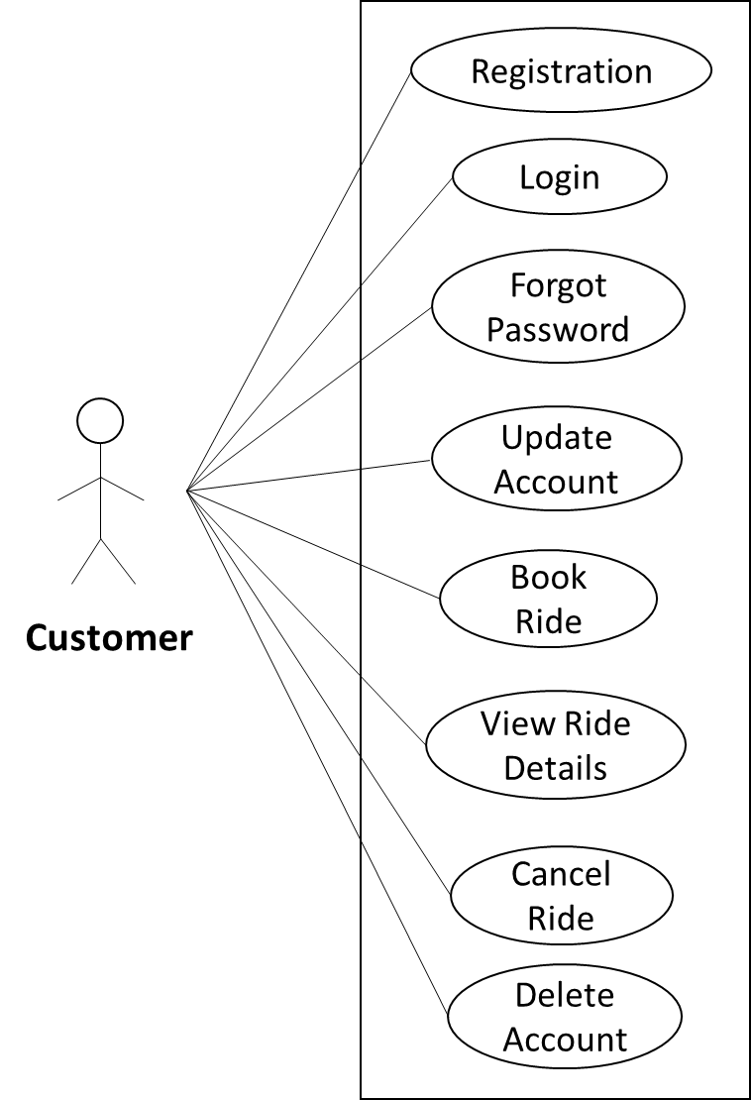

*Fig. Use case diagram for Customer*

1. In Customer use case diagram Customer is the Actor.
2. Customer can handle following use cases:
3. Registration
4. Login
5. Create Ride
6. Make payment
7. Cancel Ride
8. Accounts manipulation
9. View History

**2.4.2 Driver:**

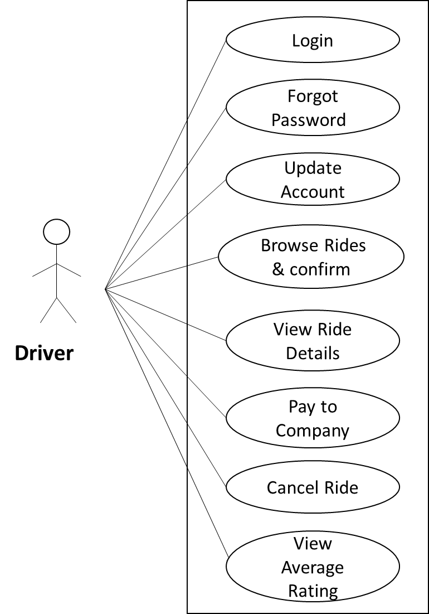

*Fig. Use case diagram for Driver*

1. In Driver use case diagram Wholesaler is the Actor**.**
2. Driver can handle following use cases:
3. Register
4. Login
5. Confirm Rides
6. Pay to Company
7. Account Manipulation

**2.4.3 Admin:**

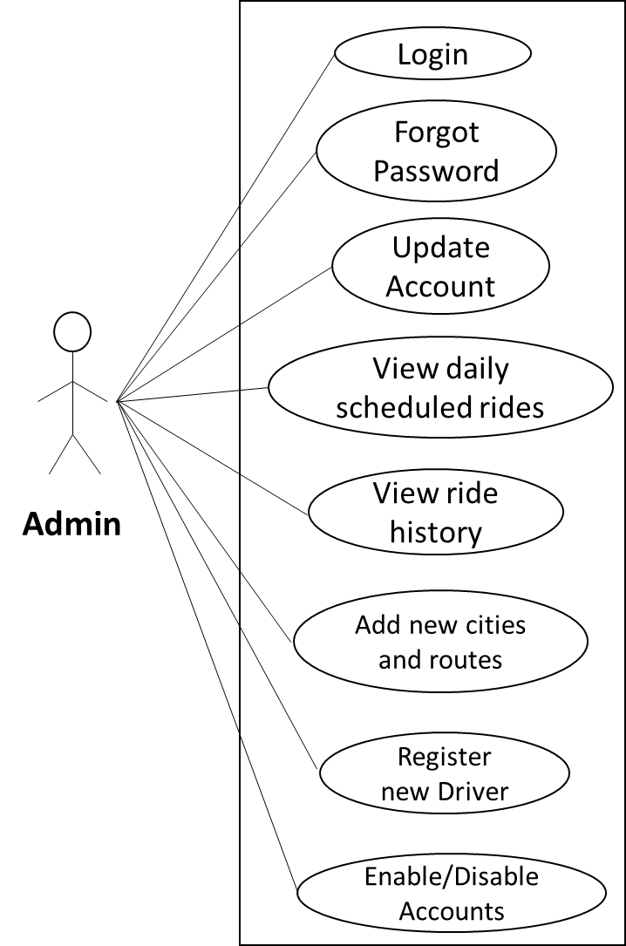

*Fig. Use case diagram for admin*

1. In Admin use case diagram Admin is the Actor.
2. Admin can handle following use cases:
3. Login
4. View Report
5. Add new routes
6. Authenticate new driver
7. Accounts management